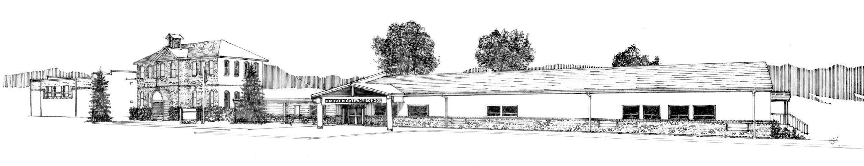

1.24.24 Agenda Special Meeting of Trustees

Facilities Committee

The special meeting of the Board of Trustees of School District #35 has been scheduled for **January 24, 2024**

at **4:30 P.M. in the library.**

**Call to Order**

**Public Comment - Non-Agenda Items**

**New Business**

Projects Outstanding for the Facilities projects

Funding opportunities

Joint Safety and Facilities meeting

**Adjournment**

The Core Purpose of Gallatin Gateway School is to embrace an engaging learning culture in a safe, nurturing environment where each student thrives now and into the future.